**Scitovsky’s criterion**

The Scitovsky criterion was developed by Tibor Scitosky in his paper “A Note on Welfare Propositions in Economics”, 1941, in order to solve the inconsistencies, -known as the Scitovsky paradox-, that [*Nicholas Kaldor*](https://www.policonomics.com/nicholas-kaldor)’s and [*John Richard Hicks*](https://www.policonomics.com/john-hicks)’ criteria presented. In order to solve these inconsistencies, he required the fulfilment of both criteria simultaneously. As an example, let’s analyse the following graph, where we consider the [*utility*](https://www.policonomics.com/utility) of two individuals (A on the x-axis and B on the y-axis), which we will compare using the utility possibility frontier of two different moments.

[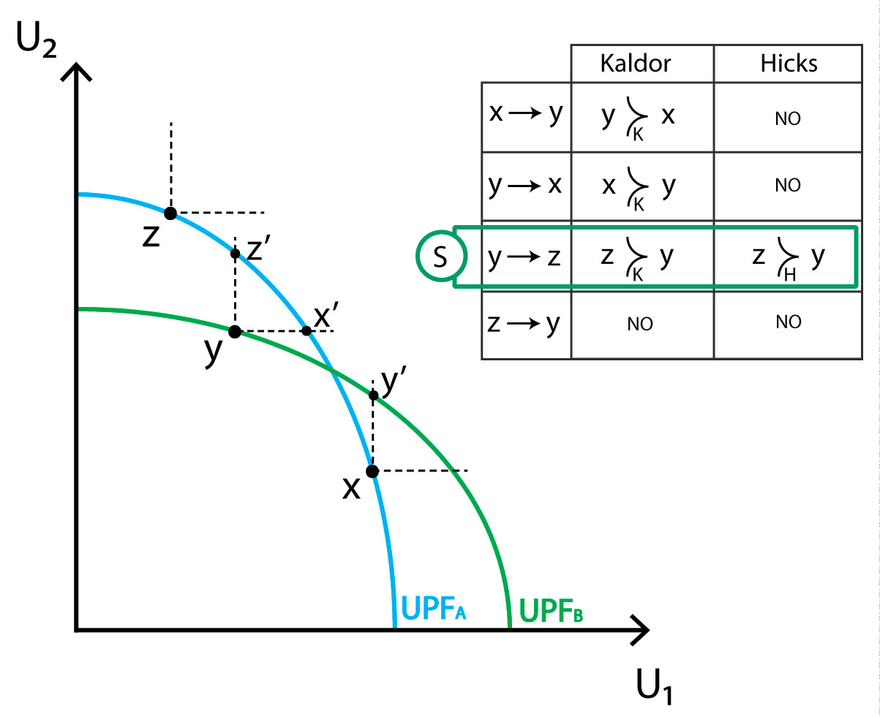](https://policonomics.com/wp-content/uploads/2016/02/Compensation-criteria-Scitovsky-criterion.jpg)

[*Kaldor’s criterion*](https://www.policonomics.com/kaldor-criterion) is met when going from X to Y, Y to X or Y to Z, but not when going from Z to Y. However, [*Hicks’ criterion*](https://www.policonomics.com/hicks-criterion) is only met when going from Y to Z. Therefore, when comparing state Y to Z, winners can compensate the loss of the losers, but losers cannot compensate the other part in order to avoid the change. This is the only case in our example where the Scitovsky criterion is met, making Z preferred to Y.

Scitovsky considered the possibility of changes in Pareto terms caused by state changes. This justified the dual requirements. Analytically,

[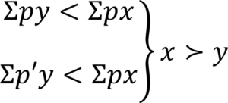](https://policonomics.com/wp-content/uploads/2016/02/formula-Scitovsky-criterion.png)

Although this criterion brings some positive contributions, there are still only minor changes that furthermore need to meet conditions. The estimation of a potential Pareto improvement is yet to be answered. Nevertheless, the Scitovsky criterion contributes to an intransitive organisation of different states